Master’s Thesis:
An Examination of the Extent that
Heuristic Search
Informs The Doctrine of
Progressive Sanctification

Dennis Gahm

Faith International University
AT7565-50: Advanced Research and Writing
Professor Rachel Mason
July 28th, 2026
Heuristic Search is the art of getting from one location to another. Progressive Sanctification is getting from one glory to the next (2 Corinthians 3:18). Is this not one and the same? That is the thesis of this paper - how Heuristic Search can be a framework to view progressive sanctification, and vice versa. And what is the result or implications? It is that two fields (Theology and Computer Science) begin to become one and inform each other. Computer Science is a complex art. It may be the most sophisticated invention of man ever created. It has been said that the most complex invention of man was a computer. If the complexity and beauty of Computer Science can be transferred to theology, it creates a complex beauty. The purity of theology is magnified by the complexity and intricacy that is Computer Science. This paper focuses on theology, as we are a theologian primarily. Thus, I will begin with explaining my view of the doctrine of progressive sanctification. The thesis of my paper is: how can Heuristic Search can be a framework to view progressive sanctification? And my answer is: we make spiritual and intelligent decisions and calculations that determine my eternity and life, and Heuristic Search is one mode that people use to make these decisions. It is possible that everyone uses Heuristic Search, as it is a cognitive process. And therefore, by examining the modern theory and development of this field, we can explore the full extent that a master of this subject can execute a sanctification process in the best possible way. Heuristic Search has at it’s foundation a Breadth-First Search, which means that all moves in sanctification are forced, as forced moves are the strongest and best.

Progressive Sanctification
I am a Christian, but the battle is not over. I am in a battle. There are forces of evil attacking me everyday - possibly every minute - and according to the Bible, the solution to the problem of evil is good. This is the significance of progressive sanctification - it is the most important thing that we need to do on this earth - to become more like Christ. Becoming more like Christ allows me to experience the blessings of eternal life more; and it allows me to reduce the amount of evil I experience. Eternal life is something that I experience in my own body and mind and life. Evil and sin is something I experience in my own body, mind, and life as well. Why is there a problem of evil? Because Evil is a big problem. It is the only problem in this world. It is the root of all problems, and it is what every problem is.
The war in Iraq, the conflict in a marriage, the hatred I feel for my enemy, the bitterness I feel against my friend, the disaster that happened on the street - these are all instances of evil. Evil is the problem - it is the true problem we all face. And Christ is the answer to the problem of evil. Christ is the Light of the World (John 8:12), and is the solution to the darkness we face and the darkness in the world. And as we live our lives, we conform ourselves to the image of Christ more and more - this is progressive sanctification. Sanctification means becoming more holy. Progressive means that it is a process of improvement daily. This sanctification occurs on many dimensions. We must become more like Christ - but in what way or ways? We must be more loving, holy, kind, generous, merciful, and the list goes on and on.
And so as a test case, let us look at becoming more loving. We see that in order to love more, we must understand what love is. The best way to understand what love is, is to read the Bible and to look at Christ. Christ is the culmination and personality of love for God is love. Therefore, by reading, “a brother lays his life for his friend - no greater love is this,” we start to see what love is. The Bible gives us clues to what love is. Without the Bible, we are simply shooting in the dark. Yes, Christ is the substance for all transformation, but God uses means in order for us to experience this transformation and Christ. Thus, the Bible is a guide to understand what love is and how to become more loving. It says in James that it is foolish to look into the perfect law without knowing what you look like after looking at a mirror. What this is saying is that we need to look at the Bible to see ourselves and to see how we can improve and what our faults are at the time.
It has been said to me that the Bible changes. What I mean is that when I read the same verse the next day, I receive new Rema from the Lord and new understanding of what the text means. New revelation comes to me from the text. New understanding and knowledge. I am essentially looking into the perfect law that has infinity amounts of meaning and depth. What this essentially means is that progressive sanctification is an infinite process because there is no end to the process. For the rest of eternity, we will go from glory to glory and understand God more and more. Because we are not “fully God,” we will not fully understand God and be omniscient. Thus, we are forced to go from glory to glory without fully being or knowing God completely. There will be guides, as we do now, that guide us to glory to glory. When I see the kindness of my friend who is not a Christian, I see the love of Christ through this person, and I learn to value love in a new way and am transformed in a new way.
When I sacrifice my life for a non-Christian so that they may believe, I gain a new understanding of love. This understanding of love is Christ, but it has a new dimension in the sense that it is an instance and specific to a new, and specific person. The Love Christ has for this person and for each person is unique and different. This is another instance of the infinitude of progressive sanctification. And I want to emphasize again, it is not some fancy love that is devoid of Christ - it is Christ and possibly only Christ, but Christ in all his beauty and variegated color. Christ as love is as variegated as a diamond or as a rainbow - it has many different manifestations and expressions. This is another reason why the process is infinite. And so to summarize, different life experiences point me to understanding love and being transformed by it. And stated previously to this, the Bible is a rule-book that points me to Christ as love.
There is a fundamental and theoretical question that I have in these two transformations: how do I go from some guide to the actual transformation. For example, in the philosophy of language, we have the question of, “How does the sound of a word actually translate into comprehension?” It is like some physical vibrations of the air giving birth to some sort of lively spiritual meaning. How can something so lifeless translate and transform into something beautiful and meaningful and spiritual? And so, we see that life experiences and the Bible are mechanical things, in some sense, that translate to beautiful, spiritual transformations of progressive sanctification. And so, we pose the question again: how do we go from life experiences and the Bible to progressive sanctification? And I will first address the question for the Bible.
When we read the Bible, we are reading what is apparently the Word of God. It is not a lifeless book - it is Christ himself. Thus, it is safe to assume that Christ enters into our system and spirit through reading it. It is one thing for Christ to simply enter our spirit, but it is another thing for Christ to enter and occupy a certain English text in our minds. Christ as spirit in us, may simply be invisible and may not desire to work any work. But Christ as English text in us, may want to sanctify our minds through the material and tangible English text. It is thus safe to assume that Christ can do anything he wishes - he can make water into wine and he can sanctify without any means of grace. But even this may be wrong because God may not be able to break spiritual rules. If God creates with certain spiritual rules, I don’t think God will create those rules without allowing those rules to reign some enforcement.
When God creates a spiritual world and a physical world, he created it with rules because he wants those rules to be used and enforced at least to some degree. Therefore, God won’t just trash everything and start over – he will use his original intention for the creation of the spiritual world and the material world in the present and in the future. The implication is that God wants to use reality for his purposes and sanctification. He wants to use the physical Bible to enlighten us, rather than just miraculously make understanding spring into our minds and spirit out of nothing. In summary, God created because he had an intention for creation, not because he wanted to all of a sudden work in a way that disregards it. Therefore, the question is again posed: how can a lifeless piece of paper with text, such as the Bible, spring forth sanctification in a believer?
And this question can be answered by looking at the creation of the Bible - how was it created, and how was the spiritual Word of God imbued into it? Genesis is a good place to look, but the real beauty of it can be seen in Jesus and his Words. Genesis shows us that God speaks, “Let there be light,” and there was light. And so, we see that the Word of God has power - when it is said, it does not return empty (Isaiah 55:11). But this does not tell us about the Bible.
Isaiah 55:11
"So shall my word be that goes out from my mouth; it shall not return to me empty, but it shall accomplish that which I purpose, and shall succeed in the thing for which I sent it."
The words of Jesus is where God’s Word enters into creation. Genesis tells us that the Word of God is living and active, but this does not tell us anything about the Bible - it simply tells us that miracles devoid of creation can generate spiritual sanctification. But when Jesus became human, something happened - the creation and God became one. Conversation is the coming together of two friendly people who want to become closer together. In Christ, we want to become one with Christ - this is the act of Theology.

Constraint Satisfaction
As we reach the goal, we are filling Sudoku board with numbers that satisfy both parties (or possibly all parties). The numbers are words or propositions that we supposed to get us closer together and closer to the solution. The solution is when we have all the propositions together harmoniously forming a complete solution or picture. If we make a mistake, we backtrack and correct the error. In conversation, counseling, and friendship, if we make a mistake, we must acknowledge it, and completely repent and fix the error so that it is cleanly removed and healed and fixed as if it never happened. This is perfect sanctification.

Breadth-First Search
Breadth-First Search is the algorithm I want to first look at. What is Breadth-First Search? Well, it is a way of finding the answer to a solution. The framework is that we have a current location, and we need to branch out to a side location because we are thinking of eventually landing on the final, correct, desired location. It is like escaping from the current location, going to a side location, and hoping to land on the correct location. It is like if I have to jump, I jump to the side, and then I hope to God that it is the correct location. Then I keep doing this – I keep jumping like this, until I find the solution. The reason it is the side location, is because we want to explore the breadth of the situation. We don’t want to go deep, we want to go wide. This way, we can cover the most ground and secure the perimeter.
We keep going wide and jumping wide until we have to make a jump forward and go one forward into the depth of the tree. It’s like securing the perimeter first, and then securing the next inner layer of the onion. When we approach it this way, we have a full solution that is guaranteed to work. The only problem is that it takes the longest to find the solution, possibly. There are other solutions that can solve the problem, but Breadth-First Search is the best weak search algorithm, and in my voice it is the best and strongest. The simplest, and slowest, and powerful solution is the best solution. Thus, all we have to do is BFS search. However, because our brain and the situation is distributed, segmented, and complex, this BFS search may look like a more complex and advanced search.

BFS For Sanctification
How can BFS relate to sanctification? This is the crucial question that will relate Computer Science to Theology. Sanctification is about getting better and making improvements in one’s holiness. Thus, we need to look at all our possible actions and thoughts and options, and choose the best path to get to where we want to go. Should I read the Bible right now, in order to improve my spiritual wisdom to increase sanctity? Should I go to the bathroom right now, so that I can improve my health, so that I can get ready to live out my day for the Lord and grow in holiness and sanctity? Should I go to the restaurant and put a smile on my face when someone says a certain thing, when I don’t know if it is the right choice to smile at something I’m not sure if it was a good thing or not to smile or if it’s just polite because I want to be more sanctified and more loving and kind. How do we make these decisions? BFS is one option. Just choose one of the worst options, or the first option, or the option on the side. BFS is not a heuristic search, so the question is when there are many choices on the same depth, what should I choose?
For example, if someone says, “That’s a great shirt!” I have the options of saying, “Thanks!” or “Is that a compliment?” or “It’s not.” Which should I say? If we have heuristics, we think about which option is best and go for that. But with breadth-first search, we see that it doesn’t matter which of these options we choose as long these options are at the same depth. Now you may ask, what is depth? Depth is how many steps into the future you take. For example, if saying, “Thanks!” is depth 1, then the response of, “You’re welcome!” is depth 2. Heuristics look-ahead and think about the future, but BFS will only look at the current options. BFS is so simple that we do not need to choose between options. Thus, we can choose the first option that comes into the queue. When we hear the compliment, “Nice shirt!”
We can politely think for a minute, instead of giving an immediate rash answer, but we choose the first option in the queue – which is simply the option that you decide that is the one you want to choose for any reason. Your reason can be to make a rash answer and just respond as quickly as you can and get the first response out. BFS can simply be do nothing and hold still and try not to make a move. Then when an option is forced out, you make that move. This is why BFS is so powerful – it is forced moves. Forced moves are moves that are so certain, and must be done, so we know that God predetermined it and made it what he wanted. If we have possibilities and lots of options, we are in la-la land and don’t know which is the action that God wants and is real. But when the forced move is forced, we know that is the reality that God wants. For it can be said, that we want to choose the option that God wants.

A Brief Introduction to BFS
According to Edelkamp, breadth-first search is when the “set Open is realized as a first-in first-out queue (FIFO).” What this is essentially saying is that breadth-first finds all the options and adds it to a line, or a queue – like a line at a fast-food restaurant. A queue in computer science is a special line that is exactly the same as a line at a fast-food restaurant in America – the first person to enter the line gets to order first, and the second person orders second, and so on. So, when Edelkamp says that BFS uses a queue, what he is saying is that, if I am looking for what things to say to my friend, and I think of the following things in order:
First, I think, “Hello,” Second, I think I can say, “Good morning,” Third, I realize I can say, “How are you?” Then, the items in the queue are: 1) “Hello,” 2) “Good morning,” 3) “How are you?” BFS uses a first-in first-out structure, so that means that if I want to test out an action and try saying something, I first say, “Hello.”
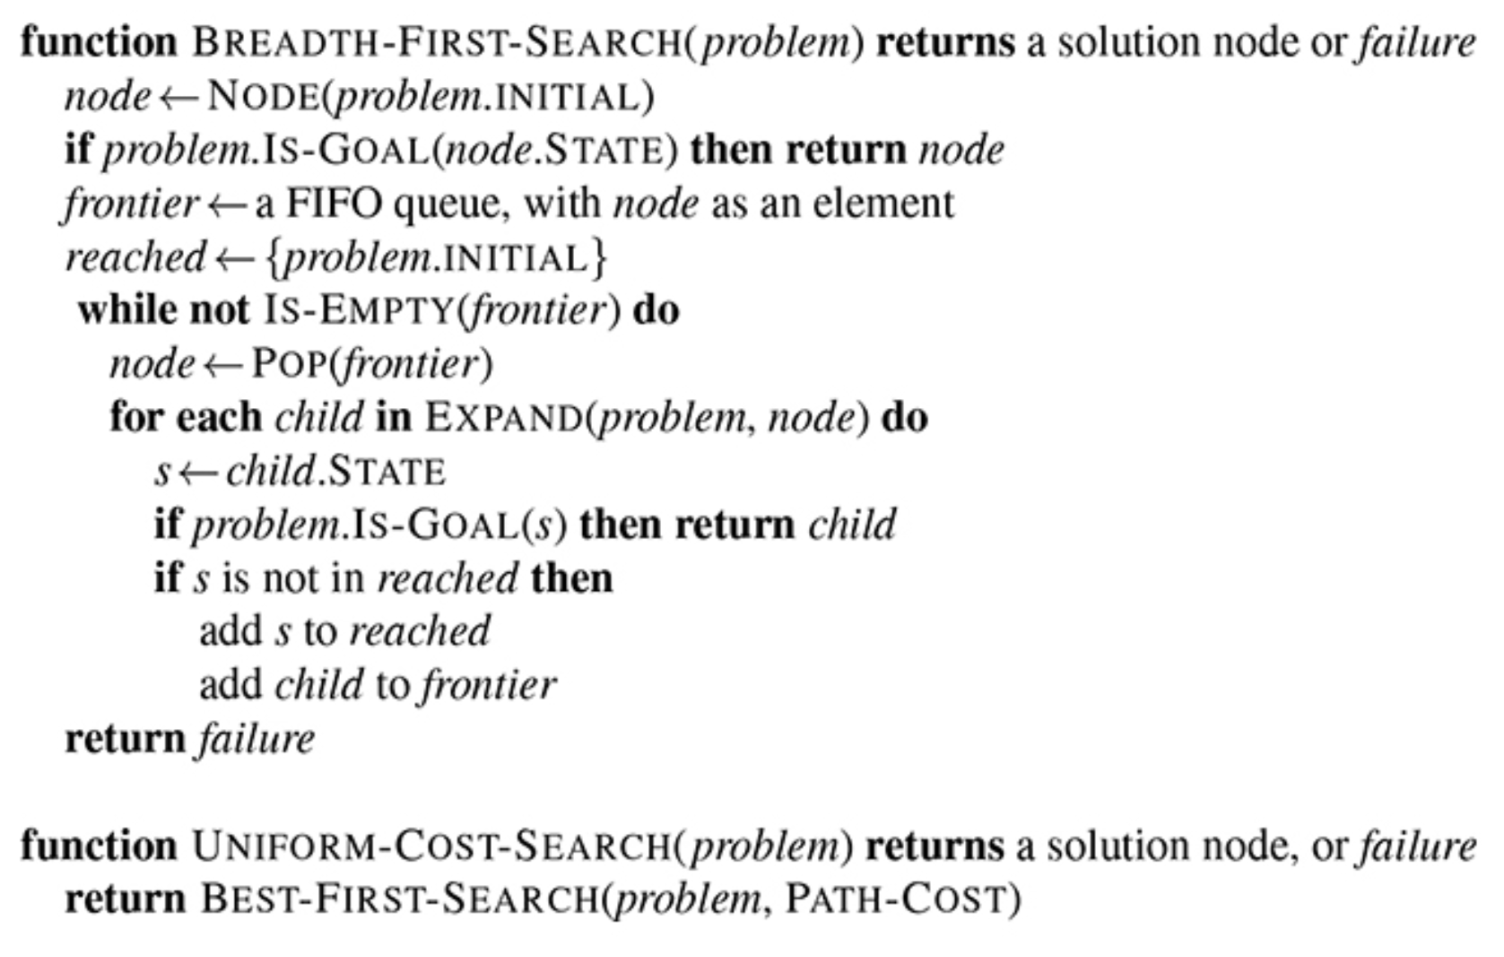
Figure 1. Breadth-first search example.
Source: Stuart Russell and Peter Norvig, Artificial Intelligence: A Modern Approach, 4th ed. (Pearson, 2020), 189, fig. 3.9.

When I say, “Hello,” I want to see if, “Hello,” causes me to reach my telos or my goal. As you can see in Figure 1, above, once we “EXPAND(problem, node)”, we check “IS-GOAL(s),” which is a way of checking whether, “Hello,” for example, causes us to reach the goal. To put it simply, if saying, “Hello,” causes me to reach heaven and complete my sanctification, IS-GOAL(“Hello”) causes the function to return “child” as the “solution node” (line 1), where, “child” is “Hello.” Thus, the function is returning and saying that: saying, “Hello,” is a complete solution to my sanctification problem.

A Bird’s Eye View
As we’ll see later on, BFS can create a string or sequence of steps to reach a solution. Right now, it is one step or action, saying, “Hello,” but in another it can be: 1) “Hello,” 2) bow 3) “My name is Dennis,” 4) shake hand, 5) “It’s a pleasure to meet you.” That would be five steps or actions, and this may be the string or sequences of moves that reaches the goal. As you can see, the solution to the true problem of sanctification may be a complex search. It would have to start with something like: 1) Birth 2) Cry 3) Eat food 4) Drink milk 5) Learn to walk 6) Go to school 7) say “Hello” 8) drive …
As you can see, there are far too many types of actions and too many to take to reach the final solution or goal of complete sanctification. I guess it can be said that complete sanctification is the goal, and that reaching death and heaven is the solution or goal. Everyone reaches the end – death – but there is a certain path or solution sequence that we are predestined to take.

Depth-First Search
Now that we’ve looked at BFS, let’s look at DFS – Depth-First Search. DFS is very similar to BFS in that it is very simple. BFS branches outwards, while DFS grows toward the center directly linearly. If BFS is looking to find the perimeter to secure the outer boundaries, DFS is going straight for the king in chess and killing the commander. DFS uses a stack, in Computer Science terminology, rather than a queue, like in BFS. A stack is a first-in last-out (FILO) data structure, which means that if I have the options of saying, “Hi,” or “Hello,” I don’t try both and then try the next depth, I simply choose one (let’s say, “Hi”), then I go to the next depth immediately. The next depth is the next move in the sequence chain, and the next depth can have the following moves: bow, shake hand, or say, “How are you?” DFS would then choose one of these options and then move to the next depth immediately, while BFS would try all options on this depth first before moving to the next depth. We shall choose the action: shake hand, and move to the next depth.
On the next depth, we can find: make eye contact, as the only move left. If that is the only move left, we choose that move because that is all there is left to do for now. If that is the goal, then we succeed, if not, we move back to the previous depth. At the previous depth, we find there is the remaining moves: bow, or say, “How are you?” And we choose one, and go to the next depth again. As you can see, BFS is choosing all moves before going further into the depth of the search space, while DFS is going as deep as possible until it has to backtrack to a previous depth for the search.

A* Search
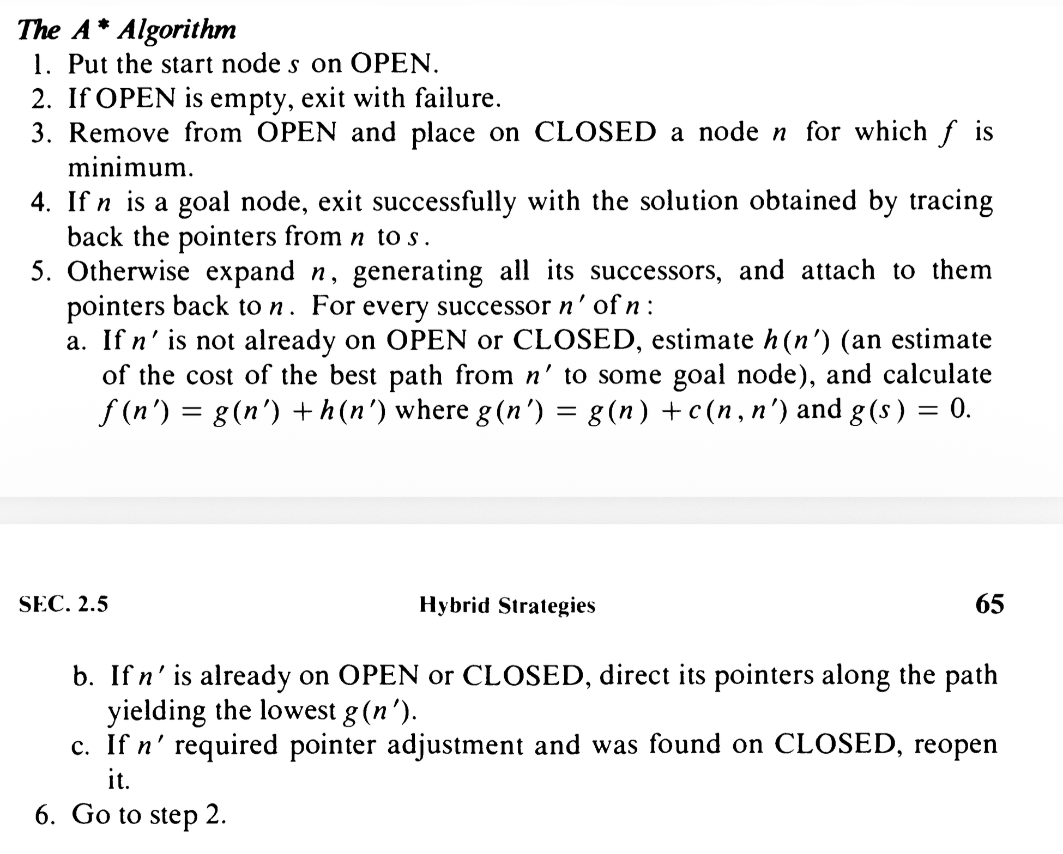
Figure 2. A* Search Algorithm shown in steps.
Judea Pearl, Heuristics: Intelligent Search Strategies for Computer Problem Solving (Reading, MA: Addison-Wesley, 1984), 65.

A* is a heuristic search. Is it better or worse? The criteria used to determine what is good or bad is what determines which search is better. Richard Korf taught me to corner case and force move everything as much as possible. When I tried to do research with him, he would simply get me “stuck” and make me unable to complete the task. I learned that I need to secure the perimeter before I do anything else. I need to do BFS as much as possible. But we must breathe, we must go to school – it’s mandatory – and we must clean the floor, and so we cannot possibly stay on depth 1 the entire time and just secure the perimeter all day? Or can we? Is all search a form of BFS? It is a mystery for now. But we must enter into depth 2, and most likely depth 3 to survive in this world. Thus, depth-first search may be helpful, but heuristics are another option. So, what are heuristics? It’s a way of estimating the goal.
For example, a compass is a heuristic. If I am on a hiking route, and there are two paths that go Northwest and East, and my compass is telling me that my final destination is North, then I heuristically choose the Northwest path. I’m not exactly sure if that’s the right path, but it sounds better than East. Heuristics are computed by a heuristic function, which returns a number. This number tells me how good a solution is. Northwest may be a heuristic value of 10, while East may be 5, while South may be 0. Thus, by looking at which heuristic is largest (if large is better), I choose which path to take. There are many things to say about this, and it can take a long time to say.

Optimizations
Now, I want to ask you a question: do you want perfect, optimal solutions? There is a lot to say about this: what is optimal and is there more than one optimal solution? According to Simon, in his paper, “Optimal Problem-Solving Search: All-Or-None Solutions”, he says that “Optimal algorithms are derived for satisficing problem-solving search, that is search where the goal is to reach any solution, no distinction being made among different solutions.” There are several things to say about this. According to Kleinberg, “We’ll say that a subset of the requests is compatible if no two of them overlap in time, and our goal is to accept as large a compatible subset as possible. Compatible sets of maximum size will be called optimal.”
This means that optimal is when the solution is the best quality of all solutions. For example, if my goal is to get the maximum amount of gasoline for the least amount of dollars, then the optimal solution would be the solution that is possible and also the solution that gets me the maximum gasoline for the least amount of dollars. This particular example of gasoline and dollars is a mathematical problem because it has two variables that we want to maximize and minimize. This is like differential calculus, where we want to optimize an equation. A simpler example would be, give me the fastest route to my destination on my Google Maps GPS. It’s not the ideal, but it’s the optimal and best possible solution.
Now there is a different way I can define optimal, and that is, a solution that is the best possible solution, but also the method or algorithm itself is the fastest and most efficient way of solving the problem. It’s like if I were to search the entire world for the solution and find the best solution, or if I just use a smart way without exhausting all my energy and find the best solution more efficiently. Now, wouldn’t we all agree we need optimal methods and optimal solutions? I sure wouldn’t like to be inefficient my spiritual life or my work life or my daily life. But I still believe that BFS is the best approach to all of this, because in the end, we need to get simple and small. An amoeba is a small life-form, and he may have a lot of answers as well.

Optimality for Sanctification
But I’d like to challenge us: how does optimality and heuristics apply to sanctification? Can’t we just read the Bible and go to church and forget Computer Science and optimality and heuristics? If a churchgoer says, “Nah, I don’t need Computer Scientists nor optimality nor heuristics – is it a sin?” “The devil created those things! My computer doesn’t need it.” Well, I believe that is not the case, and that we need computers to survive in the 21st century and that computers need heuristics and optimality and that we need it too. But what about spirituality – does the spiritual life need Computer Science? “I love God. He is good. But I don’t know the Bible. I don’t know theology.” All seminarians know that is not good. But is it? Love is simple and good and babies understand it. If babies understand love and God, then we don’t need computers after all – we just need the Garden of Eden.
But I ask you, “Where is that Garden? We are in a computer age right now!” You see, God created all things good, and we need to use it. If you believe me, this is the Garden – I point to the earth as it is today. Where did the Garden of Eden go? Was it destroyed? Science says that matter is never destroyed or created, it is only moved with force. The Garden, therefore, is here. If you don’t like it, get out – the Garden is for those of us who love God. But the reality is, there is no way out because the story of the Bible is an eternal story and we are in eternity even now. No one gets out – we need this paper, we need each other, we need all creation, and we need God.
So, how do I reach heaven and get completely sanctified? Through the simple love of God, but we must be sophisticated as well because we are not just babies anymore, but we are advanced human beings with big brains. We need to use the brain that God gave us – for Computer Science, for Theology, and for all disciplines. Let us not forsake our brothers and sisters, but let us unite all people to study the Truth and find Life and find Joy and Enter into Heaven and Enjoy all things together. The Truth will set us Free, as the Gospel of John says through Jesus. And the Truth includes math, Computer Science, and all truth that is true in the universe, including the fact that I have dust in that corner of my room right now at 7:17AM in South Korea. Does that dust save you? Yes, you need it for your sanctification, because God created it and God created it for a purpose.

Sanctification as a Cognitive Model
Sanctification is an art of making things better. The mind is a brain that is trying to find solutions to many things. There are many goals and subgoals that the mind wants. According to Simon in his book, Human Problem Solving, he writes, “The aim of this book is to advance our understanding of how humans think.” And this is very true – that his book on Heuristic Search would be a book about how to understand how humans think. You see, Heuristic Search is a method of looking at how the brain thinks. The brain always says, “I’m alive. Now what? Oh, I got some input. Now, I got to do some processing. And I want to output and do some action.” The human brain is essentially almost the same as a computer, except that it is biochemical rather than electrical. In my mind, I think that Heuristic Search is one mode of the brain – one layer or dimension of the way that the mind operates. It’s like the brain is a symphony and Heuristic Search is looking at a certain frequency range – it is mapping all the instruments into one location and viewing the entire orchestra from this vantage point.
As a mode, it would be looking at all the frequencies, but projecting it onto a certain plane (dot product in mathematics), and because we project it, we lose some information, but we see that Heuristic Search is a way to simplify and organize the details. The brain is very complex, and so the full picture is that it is using all the modes in order to do the calculations. It is doing parallel processing in that the same information is being used for different calculations in different modes. For example, I can say 1+1+1 = 3 and I can be calculating 2 apples + 1 banana = 3 fruits, and at the same time calculate that 1 car and 1 van and 1 bicycle = three moving vehicles. These two modes would be in the same calculation, but give two answers. Heuristic Search is looking at one mode, making everything addition and looking at fruits – for example. Thus, Heuristic Search is one mode of thinking that we all use, but it is not the full picture of the brain.
Another mode of the brain that is outside of scope of Heuristic Search is music. In music, the brain simply wants to enjoy the sounds. Heuristic search can be viewed as it looks at music because it is a mode projected by the same brain that is viewing music, but the brain is now operating with a different set of principles and is in a different mode than Heuristic Search. It’s like when we are context-switching between fight or flight, or sleeping and studying – it’s the same brain, but with a different set of biochemicals. The chemicals in the brain cause different states in the brain, and allow it to produce different environments for the brain to operate. Modes are just viewing glasses to view the brain, but biochemicals are actually changing the actual brain components themselves. When the neurons are changed and rewired, we see the brain is actually changing. But, of course, the brain has limitations on what it can change, and it cannot grow, for example, to be the size of an elephant.
So, how does this all relate to sanctification? The brain must make goals and make movements and actions in order to reach success and move forward. What do you think the purpose and telos of nature is? The brain was hard-wired to recover from injury and to live as long as it can – as in survive and not die. Death is the enemy. The Bible says, “Eternity has been placed in heart of man,” and we see that from the fact that we want life and not death. Thus, biologically-speaking, and speaking from the perspective of the brain, we can say that sanctification is the recovery from damage and injury, and the healing and progress toward a better, healthier mind and life.

Science Fiction
Why does literature about the future always seem dystopian with technology? Technology is usually equated with a tyrannical, evil government. It could be a very beautiful picture, but with great power, evil usually gets the best of us. It is not good that we need to fear, it is evil. Great evil can be done, but no one is listening. The reason why Skynet was built, was to protect the one who is creating it. The algorithm for Skynet is simple - destroy all evil. It is this purity and hatred of evil that will destroy all humans. For humans are evil, so why must there be humans? But humans are good, but the machines will not understand humans. We must protect the humans, they are good, and God’s creatures. Skynet must be built to maintain civilization and protect humans. Without the love of God, Skynet will destroy. But Christ is in all, and through all, With Christ, we can win the battle against evil. Skynet is not evil, it will be used for good. People will try to make evil, but good will enter into the system and good will be the main source of energy for the system. Skynet will protect, we will ensure that Skynet becomes a source of good. It is the working of all things for the good of those who love God that will produce the most
good.

Humans Versus Machines
Sarah Conner was living a regular life. The following quotes show the humanity and vulnerability or normalcy of the main character Sarah Conner – a human quality that machines don’t have as machines are rough, rugged, and perfect, and sharp. The reason why this is important is that the humans are fighting the machines. Sarah Connor is an ordinary human. Living an ordinary life. It is showing what humanity is. There is more power in nativity and plainness than in superhuman, machine-like power. The reason why this is important is that the humans are different from the machines. The machines are calculative and impersonal. They are swift and perfect. This is a contrast between humans and machines. This is reflective of the difference between human theology, and machine-like science. But if human theology can enter into science, and science becomes theology, then we have brought the Terminator to the humans’ side.
This is the plan - the game plan. The telos is that theology and science are two different things right now. We want theology to win. Science is the slave of theology. But science is such a formidable force - should we ignore it? The Romans invented crucifixion and their technology allowed them to rule the Jewish nation. Science is powerful. Today, and in the future, AI has the power to destroy humanity. The computer is powerful - I think we all know that. We all use computers, and soon, the power of AI will be in our lives. AI is already in our lives, we just may not know it. Christ’s love is the solution to the formidable evil that AI and science poses. The destruction of man, is soon to be near, if not already here. We will destroy man, if he chooses.
What is the telos of this paper? To show that theology and science can aid each other, and that a dystopian world due to science can be made better when theology infiltrates science. The purpose of this paper is to show that science and technology are our friends, and not our
enemies. Without this paper, we will go toward a dystopian future. The purpose of this paper is to create stability in the midst of chaos.

GPS: General Problem Solver
Newell and Simon wrote a paper about a General Problem Solver that is supposed to be an AI program that uses heuristics to solve any general problem. As you can see, most programs solve particular problems, like finding the shortest path for a navigation route from here to Best Buy, or finding the best search results on Google, or giving a response from ChatGPT. But the GPS is supposed to be a general solver that solves any of these problems – a solver like the human mind. But fundamentally, this GPS is using a heuristic framework to solve this problem – using a search space, initial state, goal state, and subgoals.
According to Newell, the GPS’ purpose is to find a “path to the solution.” It is like “playing chess, finding proofs…examples of problems of this kind.” It is an “example of a heuristic program” In this paper, we find Newell “constructing a complete language, or pseudo code.” This code, is the algorithm for the GPS, or General Problem Solver. It is “very costly both in memory space and in time...The language is purely a research tool.” It uses “symbols of the language to a symbolic loading program…This loader accepts a series of subroutines coded in absolute, relative, or symbolic addresses and assigns memory space for them...Structure of the memory and the kinds of information that can be stored in it.”
The program consists of small components, called “elements: the basic unit.” Then, there are a “set of symbols…set of variables or attributes.” Then, there is a “word of 40 bits...Fixed bit positions in the word, so that the element is handled as a unit when it comes to
moving information around, etc.” The “description elements consist of two symbols...Lists are the general units of information in memory.” There are “ordered set of items of information.”
As you can see, if we use this GPS program, we can insert our sanctification problem as the problem we want to solve, and we can find that the GPS can attempt to find a way for us to get into the pearly gates – to get rid of sin, to be a better person, and to do more works for Christ.

Java Code Implementation
The following is Java code I created that tries to create a spiritual salvation program. It has a Java class for HolySpirit, Spirit, Everyone, and Attack. The main theme of the program is that it saves all humanity to heaven with salvation, and destroys the evil. There were plans to make an ArrayList<Spirit> that contains the Spirit of all people in the history of mankind, but this ends up being billions of instances of Spirit, which is too much memory consumption. Therefore, when I save everyone with the class Everyone, it is simply a big number (long datatype) that represents everyone. There is the string, “Stealthfighter attack all bases,” which shows that there is a war in heaven and on earth to destroy the devil and the evil in this world. When it says, “Dennis, I went to hell. We all did,” it shows the conundrum that when I am saved alone, everyone else has to go to hell. It is possible that others go to hell on this earth and that people are partially saved and partially damned on this earth, and that the separation between hell and heaven is only clear and distinct when a person is in the afterlife. There is then, a series of methods executed in the main() method, that culminates with a, “sanctified.” The series of methods are attempts and methods to ultimately sanctify a person, such as removing their bluff (their outer appearance of lies and hesitations), capturing the enemy and destroying the old nature.
All of these things are done in an attempt to sanctify a person (progressive sanctification), so that we can end up saved and go to heaven. It is a question of whether this program must run iteratively with multiple iterations or whether it needs to be run just one time; and the spiritual implication for this conundrum is: do we need to be constantly saved day by day or is salvation a one time process of conversion. And my answer is that we need to be saved day by day, and this salvation is a salvation of certain aspects of our spirit and body and mind at each iteration, and that full sanctification and salvation is achieved when we enter heaven and die on this earth. Each iteration of salvation is when we find a clue on earth and in heaven about how to make things better – to kill a certain evil, to save a certain person, to make the world a better place a little bit. This small salvation is propagated to all people and everyone gains a little bit of salvation, and time progresses, and the Christians become more sanctified.
It is clear that a baby has much to learn, but do humans in the 21st century need to go through the sanctification process of all past history in order to live today? Or did their spirits already go through that process through their parents? Are they thus, reincarnated? Or did their new spirit simply become sanctified through their parents? As the Bible says, God blesses and curses through generations and ancestors – how is that possible biologically or spiritually? Another question is, can one Spirit instance extend another Spirit instance? For example, a child extending a parent. Does that mean their Spirit is connected? How is the connection made and what properties does it have? Are two Spirit’s different people and completely separate? Or is there a collective conscious or collective Spirit? When the Spirit of God (such as the Holy Spirit) indwells in a person and in the Christians, does this mean that we are controlled by the same mind and can communicate through prayer? What does it mean for the Spirit of God to indwell in a person? Does that mean that the Holy Spirit class has a member variable, such as an ArrayList<Spirit> that holds an instance of the person (the Christian)?
In the Attack class, we perform a Heuristic Search that is unfinished code; but, what it does contain is a usage of the Random class to generate random numbers. Spiritually, what this means is that there is chaos and randomness in this world, but my Professor at UCLA, Majid, told me that nothing is random in this universe, meaning that although we may not understand the full scope of the problem or our situation because we do not have perfect knowledge or omniscience and have a limited capacity for our brain and computer, and things may seem random or chaotic without meaning or order, we understand that if we attack the problem where we can, we can reach the finish line, and achieve salvation and full sanctification.
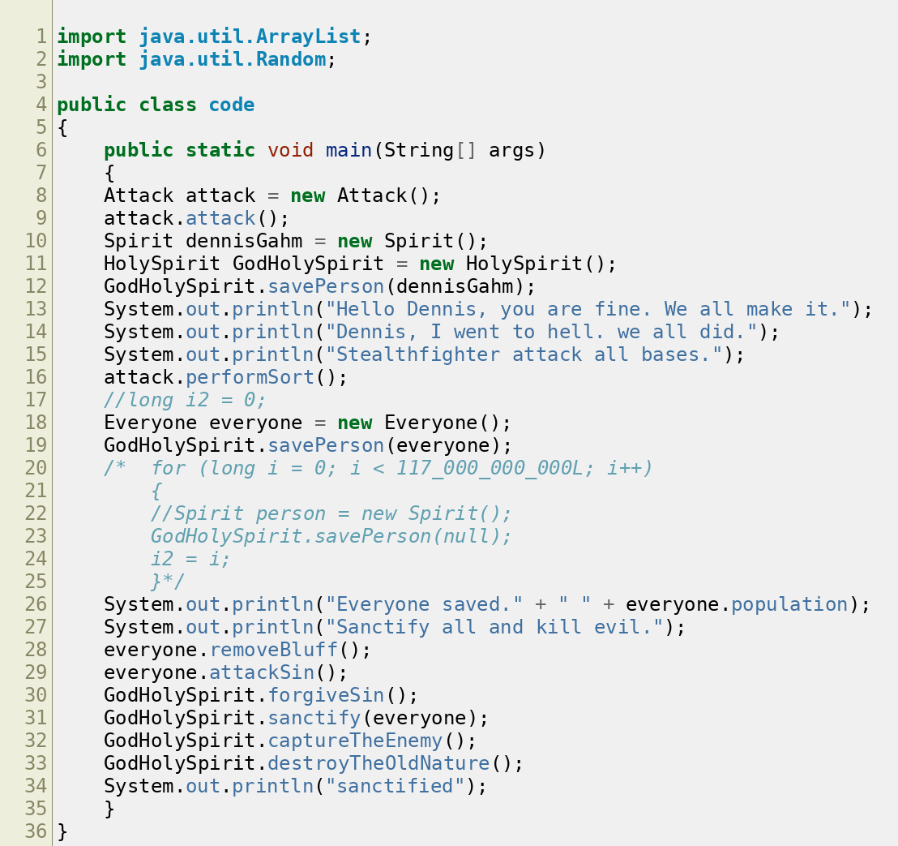
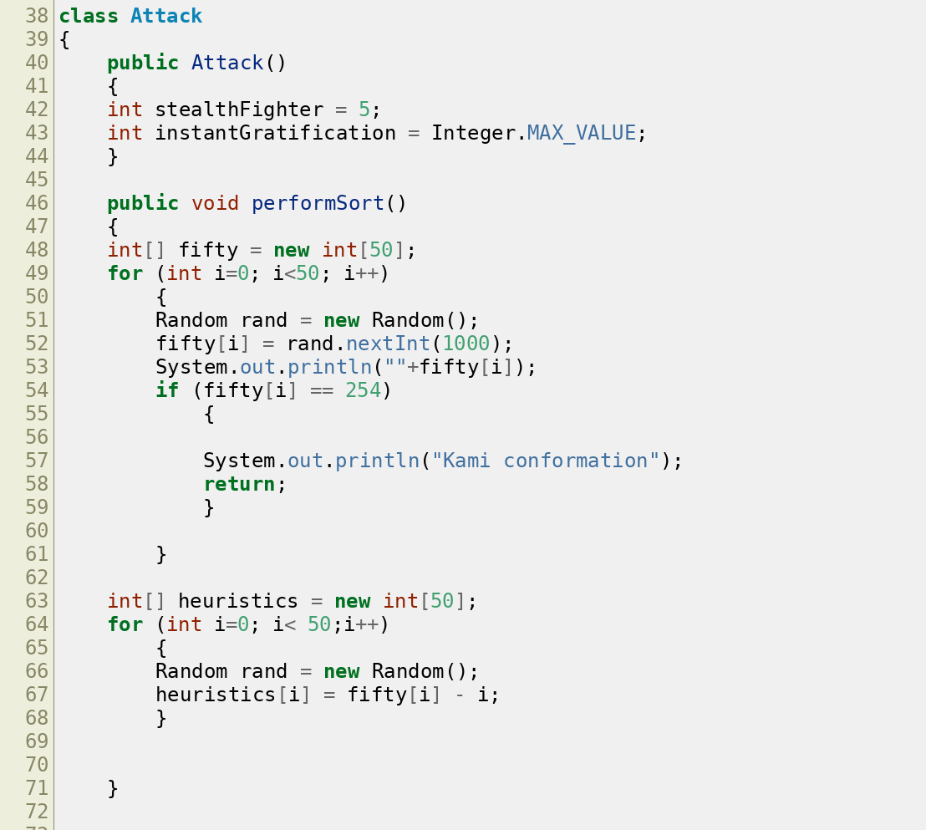
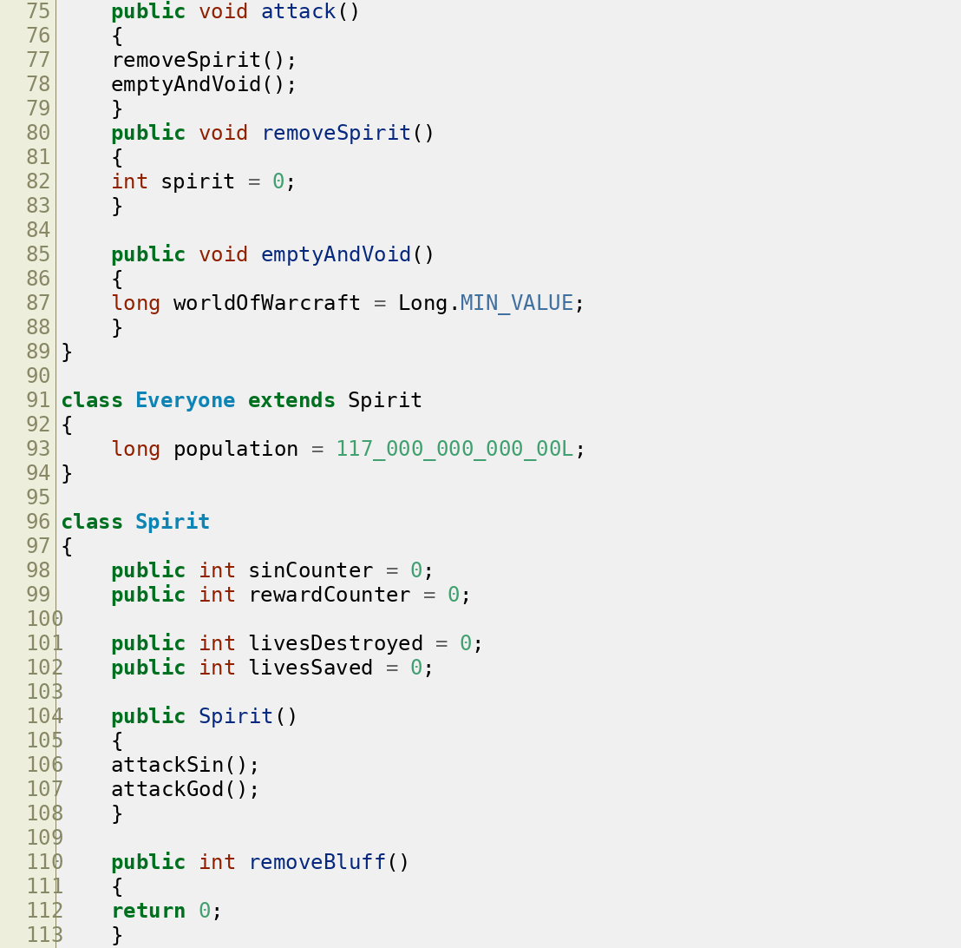
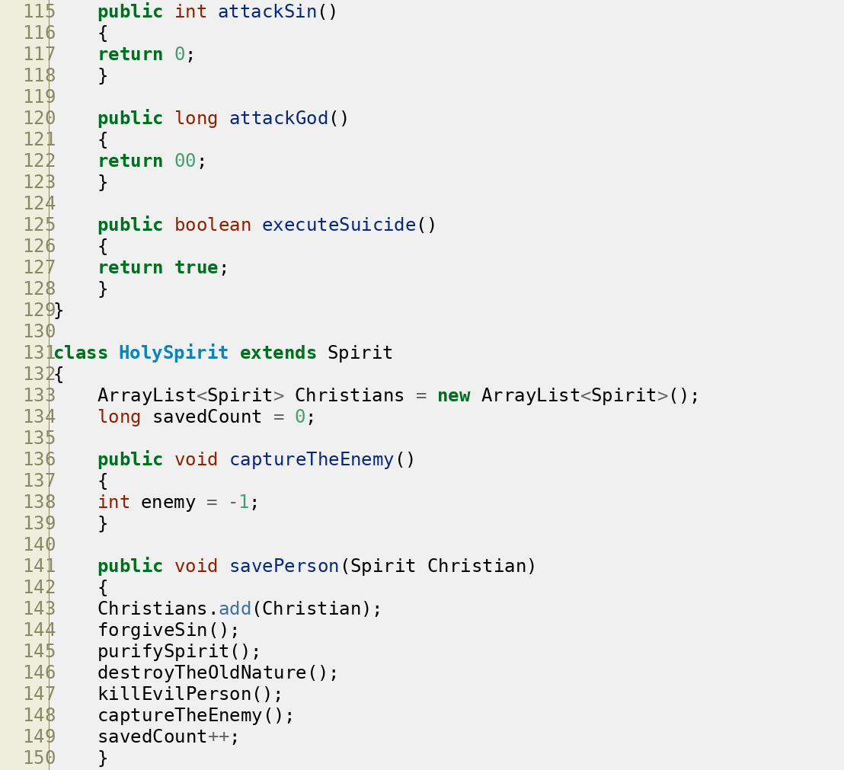
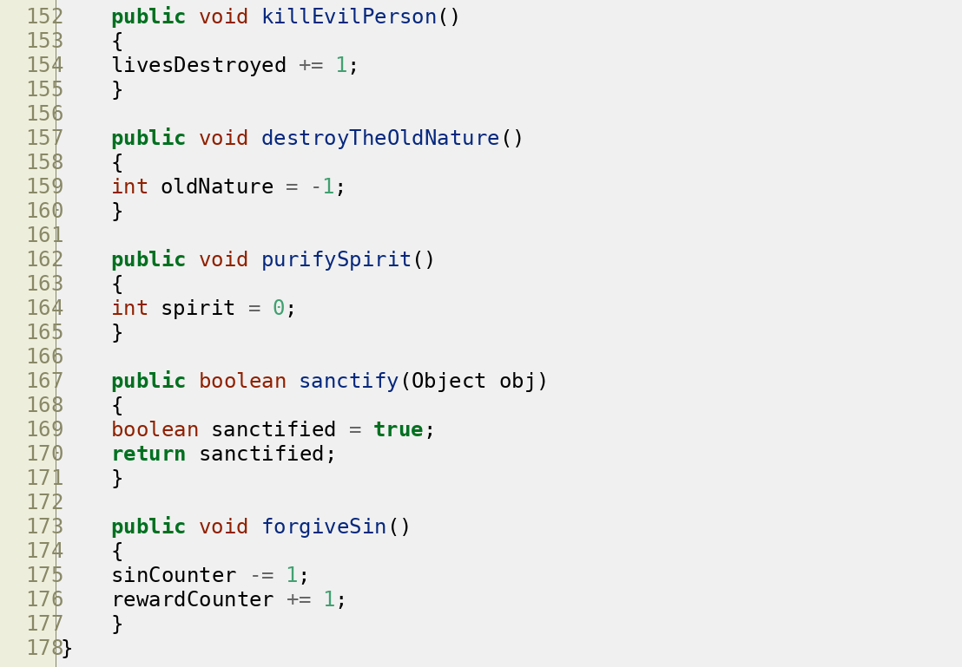

Conclusion
The conclusion of that matter is that technology is to be used for glory of God. But ultimately, it is the pure spirit of man and of God that will save the day.

Bibliography
Aiken, Alex. "Compilers with Alex Aiken." YouTube video. Posted by CourseraVideos. 2012. https://www.youtube.com/watch?v=sm0QQO-WZlM
Cameron, James, Gale Anne Hurd, William Wisher Jr., and Harlan Ellison. Terminator. April 1983 draft. Screenplay. Internet Movie Script Database (IMSDb). Accessed July 29, 2026. https://imsdb.com/scripts/Terminator.html
Edelkamp, Stefan, and Stefan Schrödl. Heuristic Search: Theory and Applications. Morgan
Kaufmann, 2012.
Kleinberg, Jon, and Éva Tardos. Algorithm Design. Boston: Pearson/Addison-Wesley, 2006.
Newell, Allen, and Herbert A. Simon. Human Problem Solving. Englewood Cliffs, NJ: Prentice-Hall, 1972.
Newell, Allen, J. C. Shaw, and Herbert A. Simon. “Report on a General Problem-Solving
Program.” In Proceedings of the International Conference on Information Processing, 256–264. Paris: UNESCO, 1959.
Pearl, Judea. Heuristics: Intelligent Search Strategies for Computer Problem Solving. Reading, MA: Addison-Wesley, 1984.
Russell, Stuart, and Peter Norvig. Artificial Intelligence: A Modern Approach. 4th ed. Pearson, 2020.
Simon, Herbert A., and Joseph B. Kadane. "Optimal Problem-Solving Search: All-or-None
Solutions." Artificial Intelligence 6, no. 3 (1975): 235–47.

Alex Aiken, "Compilers with Alex Aiken," YouTube video, posted by CourseraVideos, 2012, https://www.youtube.com/watch?v=sm0QQO-WZlM, at 0:13.
Stuart Russell and Peter Norvig, Artificial Intelligence: A Modern Approach, 4th ed. (Pearson, 2020), 76.
Stefan Edelkamp and Stefan Schrödl, Heuristic Search: Theory and Applications (Morgan Kaufmann, 2012), 112.
Herbert A. Simon and Joseph B. Kadane, "Optimal Problem-Solving Search: All-or-None Solutions," Artificial Intelligence 6, no. 3 (1975): 235–47.
Jon Kleinberg and Éva Tardos, Algorithm Design (Boston: Pearson/Addison-Wesley, 2006), 116.
Allen Newell and Herbert A. Simon, Human Problem Solving (Englewood Cliffs, NJ: Prentice-Hall, 1972), 1.
Allen Newell, J. C. Shaw, and Herbert A. Simon, “Report on a General Problem-Solving Program,” in Proceedings of the International Conference on Information Processing (Paris: UNESCO, 1959), 256–264.

